Example 1:

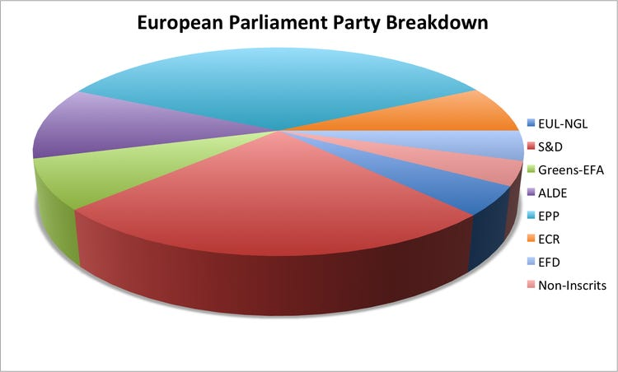

Problem:

The above data visualization picture has no indication of percentage in the pie chart and also

colors used are very similar to each other.

Fixing the problem:

By scaling the data to the percentage and mentioning on the pie chart and also by providing

with good looking colors.

Example2:

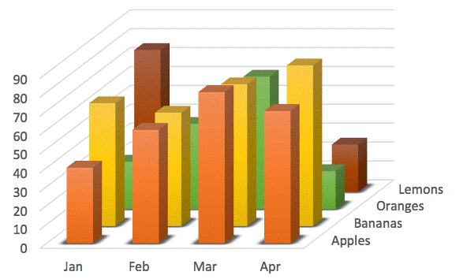

Problem:

In the chart that we cannot see the exact number for the oranges, lemons and can’t find the

values of y axis

Fixing the problem:

By creating the separate bar-charts for the individual months so that we can easily

understand it.

Example3:

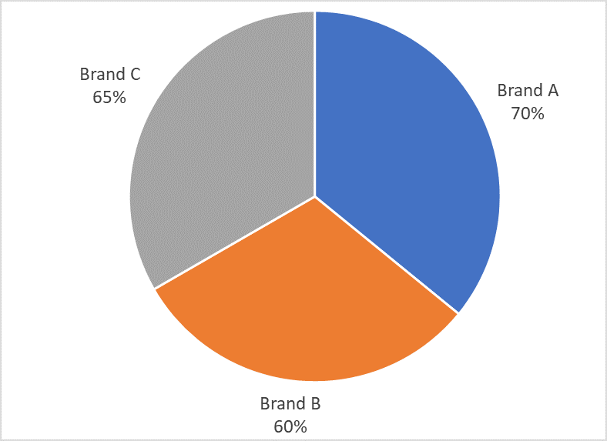

Problem:

The scaling for the brands was not equal to 100 percentage

Fixing the problem:

By scaling the pie chart to 100 percentage and also by mentioning the brand names side by.

Example4:

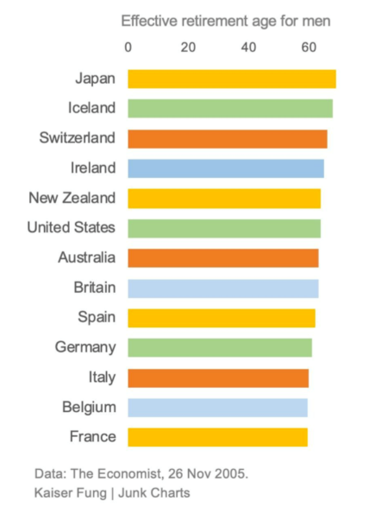

Problem:

Using the similar colors so that user can easily miss interpret the values

Fixing the problem:

BY using different colors and for each country better to make bar graph so that everyone can understand easily.

Example5:

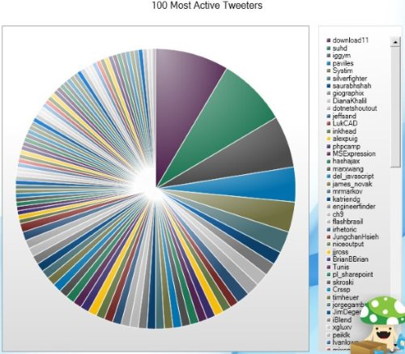

Problem:

Problem:

There are so many active tweeters as we can’t understand the users information and no

scaling was done.

Fixing the problem:

By scaling the pie chart and also mention the users by the percentage and ranking them so that

we can easily find the first and last user and know the position of user there are minute

difference can easily know who is at which position.